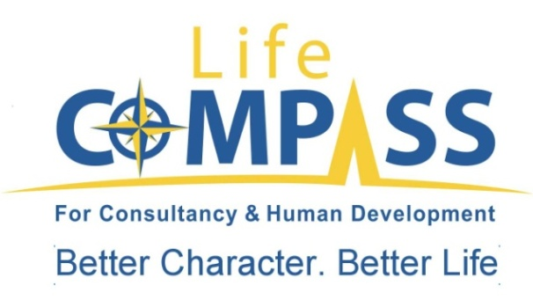

Middle Management Development program
In Association with the ministry of telecommunication, Life compass is proud to announce the start of the strategic management & middle management development program.
The training program is designed to enhance & equip the middle management with the main knowledge and up to date experience in management & strategy:
Learning objectives:
After the completion of the 25 days the candidate will:
- Acquire the up to date knowledge in Strategic Management practices
- Identify key attitudes that you can develop to enhance your managerial skills.
- Understand the expected roles a manager should be playing in the business strategy.
- Understand the management challenge and the new functions of management.
- Explore how big organization adapt it’s strategy to fit the their environment
- Explore the latest Harvard business review cases
- Discover how you can prepare for and embrace the forces of change.
- Identify ways to get you and your workspace organized and get a jump on the next crisis.
- Identify your leadership profile and explore ways to use this knowledge to improve your success as a manager.

PS : we will try as much as we can to stick to the program content & topics , however, Due to the current circumstances , the date as well as the topics covered are subjected to some changes, modification or postponing.

